1. IP configuration for Ubuntus Server Instance

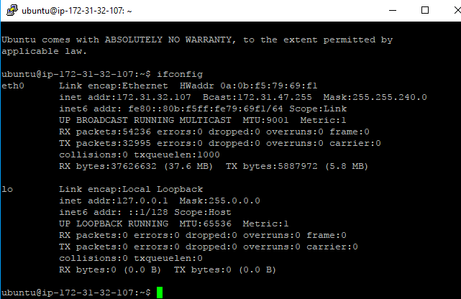

1. Ip Configuration for Red Hat Linux

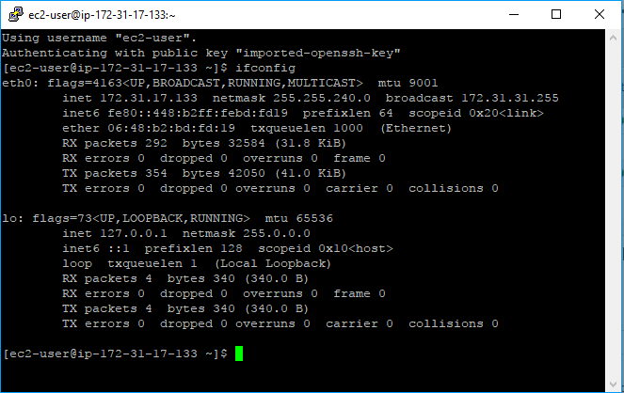

1. Ping from Red Hat instance to Ubuntu

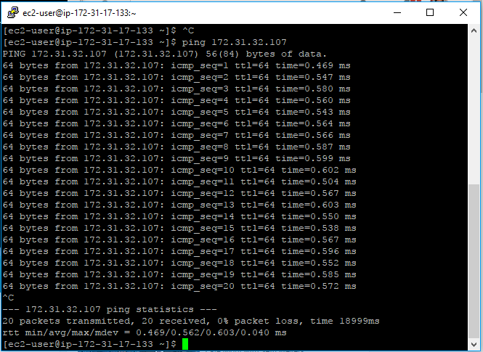

1. Installation of Hadoop

